|  |  |  |  |
| --- | --- | --- | --- |
| **CS102** | **Spring 2022/23** |  | S2G7 |
|  | Project Group |
| Instructor: | **Aynur Dayanık** |
| Assistant: | **Vahid Namakshenas** |  |

|  |  |  |
| --- | --- | --- |
| **Criteria** | **TA/Grader** | **Instructor** |
| Presentation |  |  |
| Overall |  |  |

~InsuChef ~

Meal Magicians

## Emine Fidan

**Umay Dündar**

## Edip Emre Dönger

## Elif Ercan

## Yiğit Kemal Can

**UI Design Report**

**29 April 2023**

**1. Introduction**

InsuChef is an application that designed to help people with diabetes. The InsuChef application will enable users to calculate the total carbohydrate that is consumed and calculate the sufficient amount of insulin that needs to be injected and when. That is why we designed a user-friendly, easily comprehensible, and usable interface. We made our designs by using a design website called Figma.

**2. Details**

Our application InsuChef will have the following pages:

the Launch Page,

Home Page,

Profile Page,

Meal Selection Page,

Distribution Page,

Instant Information Page,

Calculation Page,

Favorites Page,

Show Favorites Page and

Food Addition Page.

# logo içeren bir resim Açıklama otomatik olarak oluşturulduLaunch Page

“Fig 1 Launch Page of the InsuChef”

The **Launch Page** will have the application logo and name on it. This page will be shown to the user for a short time while the application is opening. Then, the user will be sent to the **Home Page (2.2).**

# Home Page

“Fig 2 Home Page of the InsuChef”

The **Home Page** has meal options and buttons that the user will choose, which are: breakfast, lunch, and dinner. After pressing one of the buttons the user will be sent to the **Meal Selection Page (2.4)** to select the food. On the **Home Page,** there will also be a navigation bar at the bottom, which has the navigation buttons in it. In the navigation bar, the first button will send the user to the **Home Page (2.2)**, and the second button will send the user to the **Profile Page (2.3).**

# 2.3 Profile Page

metin içeren bir resim

Açıklama otomatik olarak oluşturuldu

“Fig 3 Profile Page of the InsuChef”

The **Profile Page** contains information about the user. When the application opens the first time, we will direct the user to the profile page. On this page, some information that is mostly optional will be taken from the user by pressing the Update button. According to the information inputted from the user, the type of insulin calculation will change. The **Profile Page** also contains several other buttons, such as Favorites, Show Favorites, and Add Food buttons. When the Favorites button is clicked, the user will be sent to the **Favorites Page (2.8).** When the Show Favorites button is clicked, the user will be sent to the **Show Favorites Page (2.9).** When the Add Food button is clicked, the user will be sent to the **Food Addition Page (2.10).**

# masa içeren bir resim Açıklama otomatik olarak oluşturuldu2.4 Meal Selection Page

“Fig 4 Meal Selection Page of the InsuChef”

The **Meal Selection Page** contains a search bar at the top and a food list at the bottom. Users can scroll through the food list and look for the foods that they want or search the foods by name. The food list will contain foods from our database as well as the foods that the user added using the Add Food button on their profile. In the food list, the favorite foods of the user will be listed at the top of the list. The user can select food by clicking on the food's name, and after the selection, a check bar will appear next to the food name to indicate the food is selected. If the user clicks on the list item for the second time the check bar will be removed. The **Meal Selection Page** also contains a Distribution Page button at the very bottom of the page. If the user clicks that button after selecting the foods, the user will be sent to the **Distribution Page (2.5).**

# 2.5 Distribution Page

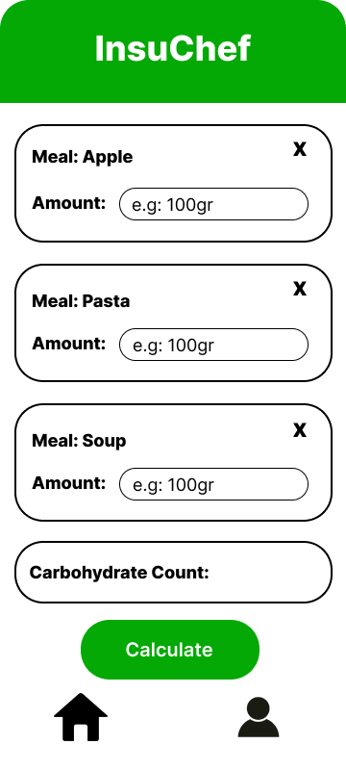

“Fig 5 Distribution Page of the InsuChef”

On the **Distribution Page,** the user will see the listed foods selected from the list on the previous page and will input the grams of each food. As the user inputs the amount, the total carbohydrate count will be shown at the bottom of the screen to inform the user. The cross buttons will be used for each food to cancel the food. If the user presses the Calculate button, the user will be sent to the **Instant Information Page (2.6).**

# metin içeren bir resim Açıklama otomatik olarak oluşturuldu2.6 Instant Information Page

“Fig 6 Instant Information Page of the InsuChef”

On the **Instant Information Page,** the user will input the instant information on the Instant Information Page, such as instant blood sugar and carbohydrate/insulin ratio. Other values used for insulin calculation, such as insulin sensitivity factor or target blood sugar, will be filled in if the user has already input this information in the **Profile Page.** If the user presses Calculate button, the user will be sent to the **Calculation Page (2.7).**

# 2.7 Calculation Page

diyagram, metin içeren bir resim

Açıklama otomatik olarak oluşturuldu

“Fig 7 Conclusion Page of the InsuChef”

On the **Calculation Page,** the results of the calculations will be shown to the user under three categories: carbohydrate consumption, insulin dose, and time. After that user can either return to the **Home Page** by clicking the first button or go to the **Profile Page** by clicking the second button at the navigation bar.

# 2.8 Favorites Page

masa içeren bir resim

Açıklama otomatik olarak oluşturuldu

“Fig 8 Favorites Page of the InsuChef”

On the **Favorites Page,** users will be able to choose their favorite meals and add them to the favorites list by using the Add button. Also, users will be able to delete their favorite meals as well by using the Delete button. As it is on the **Meal Selection Page,** users can both scroll the list and search it from the Search Bar at the top to find their favorite meals.

# 2.9 Show Favorites Page

metin içeren bir resim

Açıklama otomatik olarak oluşturuldu

“Fig 9 Show Favorites Page of the InsuChef”

The **Show Favorites** page contains the list of the user's currently favored foods. These foods will appear at the top of the food list when selecting meals. The user can click the Change button, and they will be sent to the **Favorites Page (2.8),** where they can add and remove foods from their favorites list.

# 2.10 Food Addition Page

metin içeren bir resim

Açıklama otomatik olarak oluşturuldu

“Fig 10 Food Addition Page of the InsuChef”

On the **Food Addition Page,** users will be able to add new food which is not on the food list. In order to add new food to the list the user will input the food name, carbohydrate per 100 grams, and fat per 100 grams. After inputting the required information, the user will press to the Add New Food button to add the food.

# 2.11 Additional User Interface Materials

metin içeren bir resim

Açıklama otomatik olarak oluşturuldu

“Fig 11 Snackbar and Toast Message”

The first item is called a Snackbar. Snackbars provide lightweight feedback about an operation. They show a brief message at the bottom of the screen on mobile devices (“Snackbar: Android Developers”). The second item is called a Toast Message. A toast provides simple feedback about an operation in a small popup (“Toasts Overview: Android Developers”). In our application, we will benefit from these additional user interface materials.

# 2.12 Page Diagram of the InsuChef

“Fig 12 Page Diagram of the InsuChef”

This diagram indicates the relation between the pages in the InsuChef application. In the direction of the arrows, there will be transition from one page to the another.

# 

**3. Summary & Conclusions**

In conclusion, the user interface of InsuChef has been designed to be simple, straightforward, and easy to use. Diabetes affects people of all ages, backgrounds, and technological proficiencies. The user-friendly interface of InsuChef ensures that the app is accessible to everyone.

# References

1. “Toasts Overview: Android Developers.” *Android Developers*, <https://developer.android.com/guide/topics/ui/notifiers/toasts#:~:text=A%20toast%20provides%20simple%20feedback,automatically%20disappear%20after%20a%20timeout>.
2. “Snackbar: Android Developers.” *Android Developers*, <https://developer.android.com/reference/com/google/android/material/snackbar/Snackbar#:~:text=Snackbars%20provide%20lightweight%20feedback%20about,be%20displayed%20at%20a%20time>.